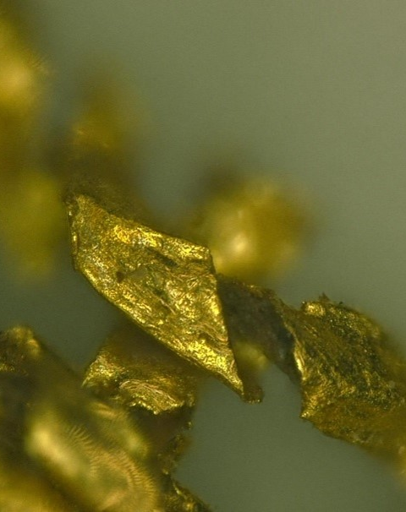
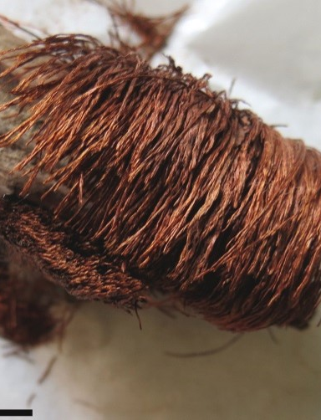

A3Tex International Workshop
“Archaeology and Archaeometry of Ancient Textiles: Analytical methods, conservation, and dissemination in textile research”
Dipartimento di Scienze dell’Antichità - Sapienza University of Rome
9th-10th June 2022
Aula di Archeologia, Museo dell’Arte Classica, Facoltà di Lettere e Filosofia

For online participation via ZOOM, please register here: https://skjemaker.app.uib.no/view.php?id=12586393

In recent years, the Department of Scienze dell’Antichità at the Sapienza University has carried out two main projects on Textile Archaeology: “Textile Culture at Pompeii” and “A3Tex. Archaeology and Archaeometry of Ancient Textiles. Continuity and Transformations of textile technologies in the Ancient and Post-Antique Mediterranean” (Sapienza Awards 2018) directed by Marco Galli. The research activities have been fueled by fruitful transdisciplinary cooperation with the Sapienza Departments of Chemistry, Physics, Environmental Biology, and SARAS, and, last but not least, with many other national and international Research Institutions, including the Directorate of Conservation at the Hellenic Ministry of Culture, ISPC-CNR (Istituto di Scienze del Patrimonio Culturale) and INFN (Istituto Nazionale di Fisica Nucleare), making the Sapienza A3Tex-Project a cutting-edge laboratory in the field of textile research.

The A3Tex INTERNATIONAL WORKSHOP aims to present not only the ongoing projects carried out by Sapienza in textile studies but also to bring together scholars and researchers who are deeply involved in investigating archaeological textiles. The workshop seeks to provide a space for discussion of methodological approaches to, and future perspectives on, textile manufacturing in antiquity, as well as on diagnostic, first-aid conservation of textile and related materials.

The meeting will be held in a hybrid form, offering the opportunity to take part in person and to connect virtually with other meeting attendees. It will be possible to follow the event on YouTube live streaming.

With the aim of sharing the results of ongoing research, methodological approaches, and important case studies capable of underlining interdisciplinarity and innovation in textile research, the workshop will take place over two consecutive days with presentations from invited speakers on the following topics:
1. Value and potential of the study of textiles in the scholarly field of archaeology;
2. Excavation, recovery, and documentation of archaeological textile finds;
3. Microscopy techniques applied to the study of textile surfaces and fibers;
4. Archaeometric and diagnostic methods/techniques for the analysis of organic fabrics, fibers, and dyes;
5. Investigation of the state of conservation and restoration of archaeological fabrics;
6. Analysis of golden fabrics and threads;
7. Dissemination and exhibition of ancient textiles.
Interdisciplinarity is highly recommended; archaeologists specializing in different chronological periods, conservators, and material science specialists are invited to present data from their research.

The organizers,
Francesca Coletti, Marco Galli - Sapienza University of Rome
in partnership with
Christina Margariti, Sapienza Distinguished Visiting Scholar 2022 (Directorate of Conservation of Ancient and Modern Monuments, Hellenic Ministry of Culture and Sports)
EuroWeb Europe through Textiles (CA 19131), organisation of online activities: Hana Lukesova, University of Bergen - Francisco Gomez UNIARQ, University of Lisbon.

For online participation via ZOOM, please register here: https://skjemaker.app.uib.no/view.php?id=12586393

